Binary Search Problems

# How many Time array rotated

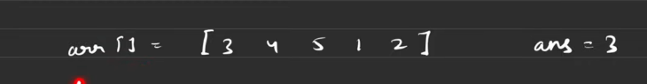

If I take the measure of min in the sorted array then I can say the array is rotated this much amount of time